**Vocabulary matching**

1 - G

2 - N

3 - E

4 - L

5 - C

6 - F

7 - A

8 - O

9 - I

10 - J

11 - D

12 - B

13 - K

14 - M

15 - H

**Scenario *Vince’s Vinyl* Ch.4**

Vince’s ERD diagram is followed in the next page...

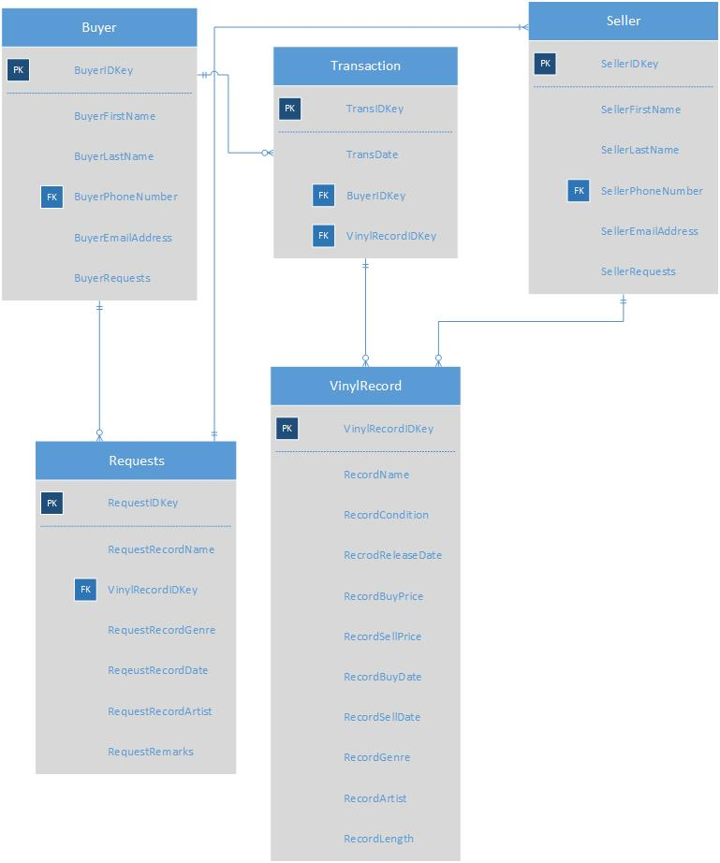

Vince’s ERD Diagram